Western Australian Certificate of Education
Semester 1 Examination, 2017

Question/Answer Booklet
COMPUTER
SCIENCE
Unit 1: Year 11 ATAR
Student Number: In figures
In words

Time allowed for this paper
Reading time before commencing work: ten minutes
Working time for paper: two and a half hours

Materials required/recommended for this paper

To be provided by the supervisor
This Question/Answer Booklet
Multiple Choice answer sheet

To be provided by the candidate
Standard items: pens, pencils, eraser, correction fluid/tape, ruler, highlighters

Special items: non-programmable calculators, MATHOMAT and/or Mathaid and/or any system flowchart template

Important note to candidates
No other items may be taken into the examination room. It is your responsibility to ensure that you do not have any unauthorised notes or other items of a non-personal nature in the examination room. If you have any unauthorised material with you, hand it to the supervisor before reading any further.
Structure of this paper

Section | Number of questions available | Number of questions to be answered | Suggested working time (minutes) | Marks available | Percentage of exam
Section One:  Short answer | 20 | 20 | 65 | 70 | 40
Section Two:  Extended answer | 4 | 4 | 85 | 72 | 60
 |  |  |  | Total | 100
Instructions to candidates

1. The rules for the conduct of Western Australian external examinations are detailed in the Year 12 Information Handbook 2017. Sitting this examination implies that you agree to abide by these rules.

2. Write your answers in the spaces provided in this Question/Answer Booklet. A blue or black ballpoint or ink pen should be used. Wherever appropriate, fully labelled diagrams, tables and examples should be used to illustrate and support your answers.

3. You must be careful to confine your responses to the specific questions asked and to follow any instructions that are specific to a particular question. Where no specific instructions are given, you should feel free to use a range of formats to express your knowledge and understandings.

4. Spare pages are included at the end of this booklet. They can be used for planning your responses and/or as additional space if required to continue an answer.
- Planning: If you use the spare pages for planning, indicate this clearly at the top of the page.
  - Continuing an answer: If you need to use the space to continue an answer, indicate in the original answer space where the answer is continued, i.e. give the page number. Fill in the number of the question(s) that you are continuing to answer at the top of the page.

Section One: Short answer 40% (70 Marks)
This section contains 20 questions. You must answer all questions. Write your answers in the spaces provided.
Spare pages are included at the end of this booklet. They can be used for planning your responses and/or as additional space if required to continue an answer.
  - Planning: If you use the spare pages for planning, indicate this clearly at the top of the page.
  - Continuing an answer: If you need to use the space to continue an answer, indicate in the original answer space where the answer is continued, i.e. give the page number. Fill in the number of the question(s) that you are continuing to answer at the top of the page.

Suggested working time: 75 minutes.

Question 1 (2 marks)
A senior analyst has asked a team member to create a prototype.
- Outline a description of a prototype. (1 mark)
Description | Mark
A working system that is created in the design stage to test ideas, etc. | 1
Total | 1
Note: Answers may state that the system does not have all aspects etc. Professional judgement.

- Outline a reason that the analyst has asked for the prototype. (1 mark)
Description | Mark
To test an idea to ensure they are on the right track etc.. | 1
Total | 1

Question 2 (3 marks)
The help desk receives a call stating that the printer will not print. Outline three steps that you would take to rectify the problem.
Description | Mark
One logical step | 1
Two logical steps in correct order | 2
Three logical steps in correct order | 3
Total | 3
The steps need to be in an order that makes sense for a help desk. Sample below.
- Check the cables are plugged in
- Check the printer is on
- Check there are no jams
- Contain paper, etc.

Question 3 (5 marks)
The System Development Life Cycle (SDLC) is a useful process in developing new systems. It comprises of a number of stages.

- Describe two types of implementation strategies that can be used in this stage.
(2 marks)
Description | Mark
Describes one type of implementation strategy | 1
Describes two types of implementation strategy | 2
Total | 2
Because the syllabus does not state which strategies can be used students may have others such as plunge, etc. That is acceptable. The ones we tend to know are direct, phased, pilot and parallel.
- Describe two activities that occur in the development stage. (2 marks)
Description | Mark
Describes one activity that occur in the development stage | 1
Describes two activities that occur in the development stage | 2
Total | 2
Because the syllabus does not state which activities occur students may have others than stated. Activities would include programming the system, creating the database, purchasing hardware, etc.
- Describe a key document that is created during the preliminary analysis stage. (1 mark)

Description | Mark
A feasibility report or a system report, etc. that outlines aspects of the problem | 1
Total | 1
Name of the document is not relevant. The document needs to state a long the lines that a preliminary analysis occurred and that the system was seen if it would work, etc.

Question 4 (3 marks)
Outline the key activities that occur in the boot up process when a computer is turned on.
Description | Mark
- The power on activates the power supply and sends power to the motherboard and components where the POST test is performed which checks for hardware failures. A single beep says all is ok.  - PC displays details on monitor including information of the BIOS. The BIOS attempts to access first sector of drive designated as the boot disk.  - Confirmation occurs and loads boot loader into RAM which launches OS into memory | 1  1  1
Total | 3
Marks are awarded for key activities similar to those outlined above. Students may break them up or group them further. They need to discuss POST, BIOS and RAM for the three marks

Question 5 (2 marks)
The following Entity Relationship Diagram (ERD) has a number of errors.
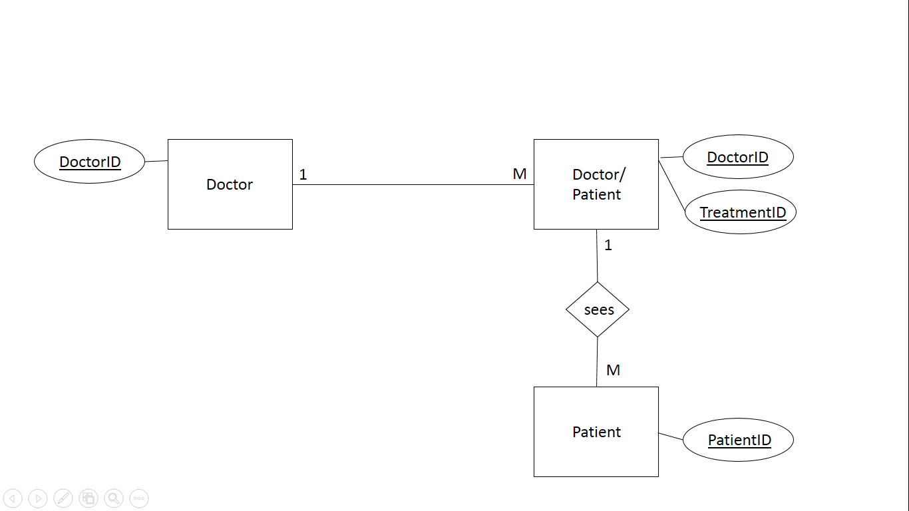
Identify two errors in the ERD.
Description | Mark
Doctor to Doctor/Patient does not have the relationship diamond | 1
No FK shown in Doctor/Patient entity | 1
Total | 2
Also the wrong cardinality from Doctor/Patient to Patient

Question 6 (3 marks)
Describe the purpose of the following database terms.

Description | Mark
Primary Key –a unique value for each row of data | 1
Cardinality - the relationship of Entity to the other and is used to explain how each table links together. 1:1, 1:M, M:N | 1
Entity – a table that contains records in a database | 1
Total | 3

Question 7 (3 marks)
The specifications of the laptop below are noted on the right side.
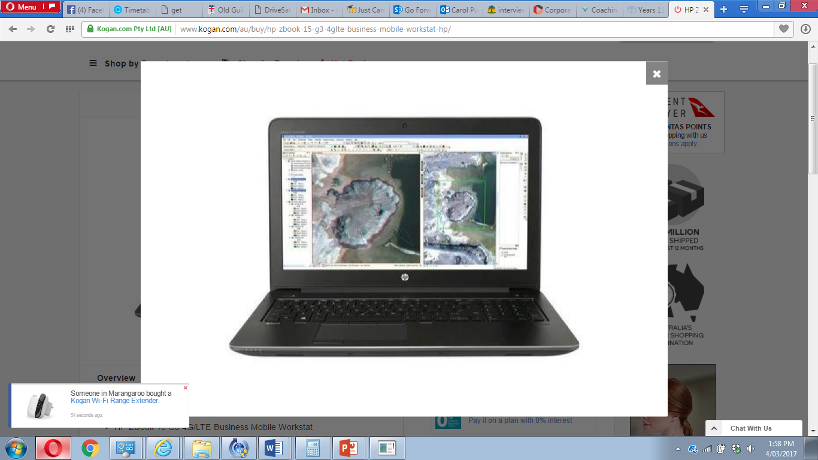 | - HP ZBook 15 G3 4G/LTE Business Mobile Workstation  - Notebook 15.6” 1080p Full HD i7-6700HQ 32GB DDR4 RAM 512GB SSD Quadro M2000M 4GB Graphics Win7Pro  - 64bit (Win10Pro Lic) 3yr Onsite  - Dimensions: 42cm x 30cm x 12cm  - Weight: 3.0kg  https://www.kogan.com/au/buy/hp-zbook-15-g3-4glte-business-mobile-workstat-hp/
Using the above information identify the storage capacity for the following:
Description | Mark
Hard drive – 512GB | 1
Graphics Card – 4GB | 1
RAM – 32GB | 1
Total | 3

Question 8 (4 marks)
Using your knowledge of computer systems, identify one item for each of the following categories.

Description | Answer | Mark
Input | Keyboard, Mouse, etc | 1
Processing | CPU | 1
Output | Monitor, printer, speaker, etc. | 1
Storage | RAM, Hard drive, etc. | 1
Total |  | 4

Question 9 (2 marks)
JBC Inc. have recently employed a systems manager. She notices that the company has no standard operating environment (SOE) and instead has a multitude of devices.
Outline two advantages that an SOE can bring to an organisation.
Description | Mark
Can include but not limited to:  Easy to upgrade and maintain HW and SW on identical machines  Costs are less as bulk SW licensing and HW purchases can be made  Saves time to install and maintain system using processes such as imaging  Essential upgrades and fixes can be tested and then rolled out. | 1
 | 1
Total | 2
Marks awarded for logical advantages.
Question 10 (3 marks)
Describe how the data, address and control bus work together to process data.
Description | Mark
The data bus contains the contents that have been read from the memory location or are to be written into the memory location.  The address bus determines the location in memory that the processor will read data from or to.  The control bus manages the data flow between components and the CPU.  They all work together to ensure that the CPU has the data it needs to process | 1
1

1
Total | 3
Question 11 (4 marks)
Describe the activities that occur during the fetch execute cycle.
Description | Mark
The CPU fetches the instruction from main memory and stores it into register. | 1
Once fetched the Control unit decodes the instruction | 1
The instruction is then executed by the ALU | 1
The result is stored in a register | 1
Total | 4
Answers can include the components but not necessary. As long as they describe what happens at each of the four steps.

Question 12 (4 marks)
Preventative maintenance is a process that should be undertaken regularly. Complete the table below and outline an activity that should be completed for each of the time periods. An example has been shown.

Description. |  | Mark
Time Period | Activity
Example - Daily | Scan for viruses
Daily | Could include: backup data,  scan hard disk file systems for errors | 1
Weekly | Clean monitor screen  Defragment hard disks  Scan for hard disk read errors  Full back up | 1
Monthly | Clean mouse and keyboard  Check for full hard disk volumes  Update virus definition files | 1
Quarterly | Check power protection devices  Check back ups are working | 1
Total |  | 4
These are suggested activities. Answers may include others that are applicable.
Question 13 (4 marks)
Each of the following terms belong to the hierarchical structure of data.
Identify the alternative name for each of these.

Description | Answer | Mark
Character | Byte | 1
Record | Tuple | 1
Table | Entity or relation | 1
field | Attribute | 1
Total |  | 4

Question 14 (3 marks)
Susan has just joined Fortune Group and has been asked to sign an ICT Code of Conduct.
a). Describe what is the purpose of a ICT Code of Conduct.
Description | Mark
A code of conduct is a voluntary set of rules, which people agree to follow or abide by. | 1
Total | 1
Marks awarded for logical purpose.

b). Identify two clauses that an ICT Code of Conduct is likely to contain.
Description | Mark
A clause may state employees are to use the internet or social media | 1
A clause may state that employees cannot share passwords, etc. | 1
Total | 2
Marks awarded for logical clauses.
Question 15 (6 marks)
The following table has a combination of spreadsheet term and definitions. Complete the blanks in the table by either identifying the correct term or giving a definition.

Term | Definition | Mark
Function | Uses predefined formulas such as sum | 1
formula | Can create a calculation starting with = sign | 1
Cell | A specific location in a spreadsheet | 1
label | Text to state what is in the row or column etc. | 1
Worksheet | A grid of columns and rows | 1
vlookup | searches for a lookup value in the left most column of a section called the table array | 1
Total |  | 6
Answers for definition may vary.

Question 16 (6 marks)

- Describe the purpose of encryption. (1 mark)
Description | Mark
To protect data through scrambling information into an unreadable format in order for it to be protected from undesirables. | 1
Total | 1
Marks awarded for logical answers.

- Describe how biometrics work in protecting data and name an example. (2 marks)
Description | Mark
Biometrics uses Biometric Authentication as the method of accessing data through the use of identification using biometric information, | 1
such as eyeprint, faces, fingerprints or voice. . | 1
Total | 2
Marks awarded for logical answers.

Describe three characteristics of a strong password. (3 marks)
Description | Mark
Length must be over a certain number of characters maybe 12 | 1
Combination of Upper and lower case letters | 1
Contain a number and/or a symbol | 1
Total | 3
Marks awarded for logical advantages.
Not names, etc.

Question 17 (4 marks)

The following is a spreadsheet identifying the number of enrolments in a college.
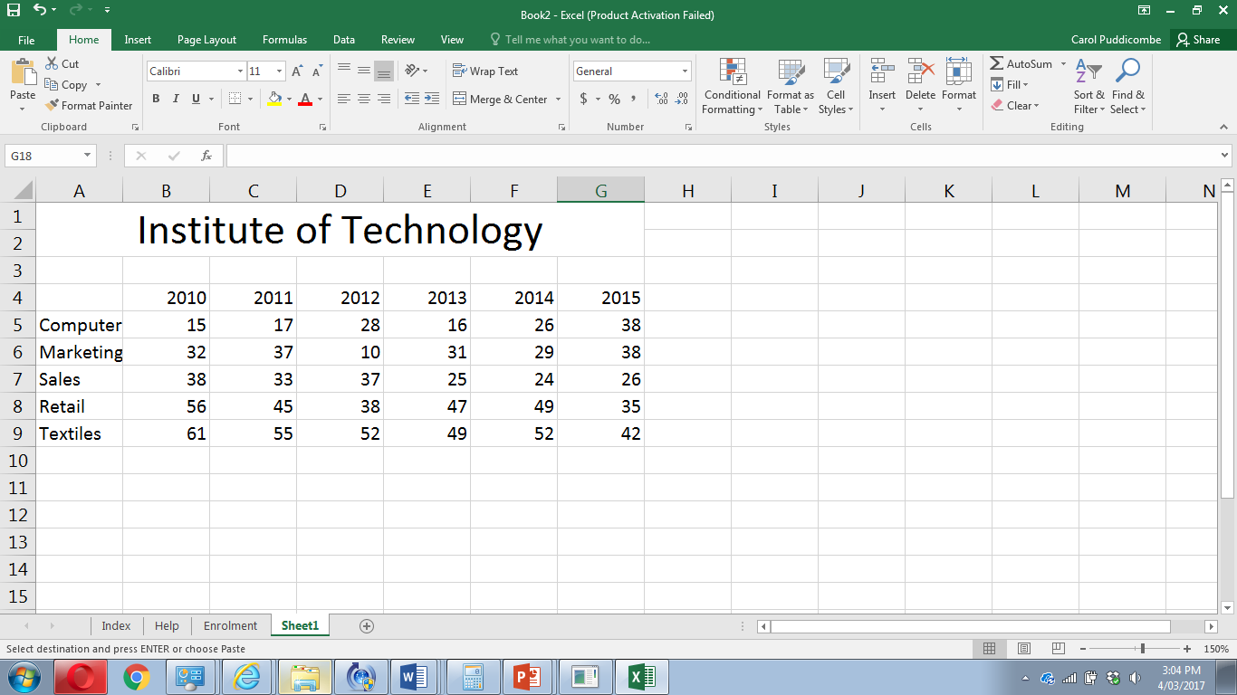

A chart is required to support the data in a report. Choose one chart below and outline your reasons why you believe it should be included in the report.

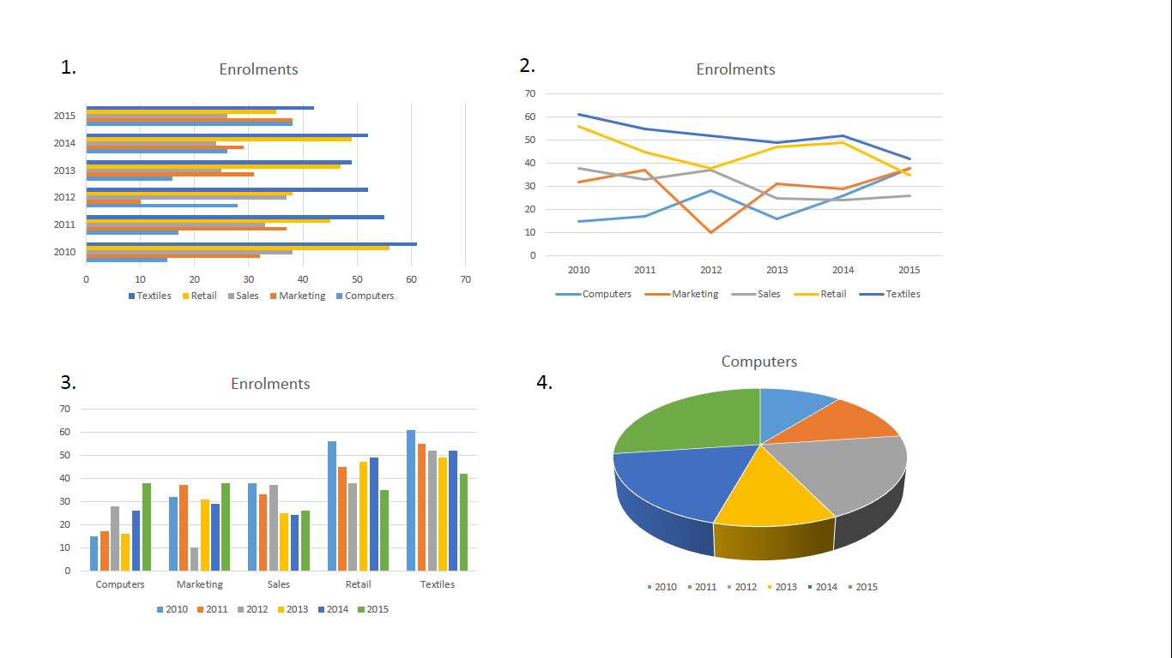
Choice
Description | Mark
Shows all of the years | 1
Shows all of the categories | 1
Shows all of the values for the categories and years | 1
Easily read and clearly shows what is in the spreadsheet | 1
Total | 4
Charts 1-3 are acceptable but not 4 as it only shows computers.

Question 18 (3 marks)

Describe the following database terms:

Description | Mark
Relation  Each table (which is sometimes called a relation) contains one or more data categories in columns | 1
Atomicity  the value of each attribute contains only a single value from that domain | 1
Record  a row—also called a record or tuple—represents a single, implicitly structured data item in a table | 1
Total | 3

Question 19 (3 marks)

Describe how cache works.
Description | Mark
CPU will look for the next bit of data to load and will check L1 cache first – if it is there it is a cache hit | 1
If it is not in L1 it is a cache miss and then will go to L2 | 1
If not there it will continue to L3 and then RAM | 1
Total | 3
Answers need to include cache hit and cache miss and how the CPU then goes through the levels and RAM to find the data

Question 20 (3 marks)

Use the following Context Diagram to answer the questions.

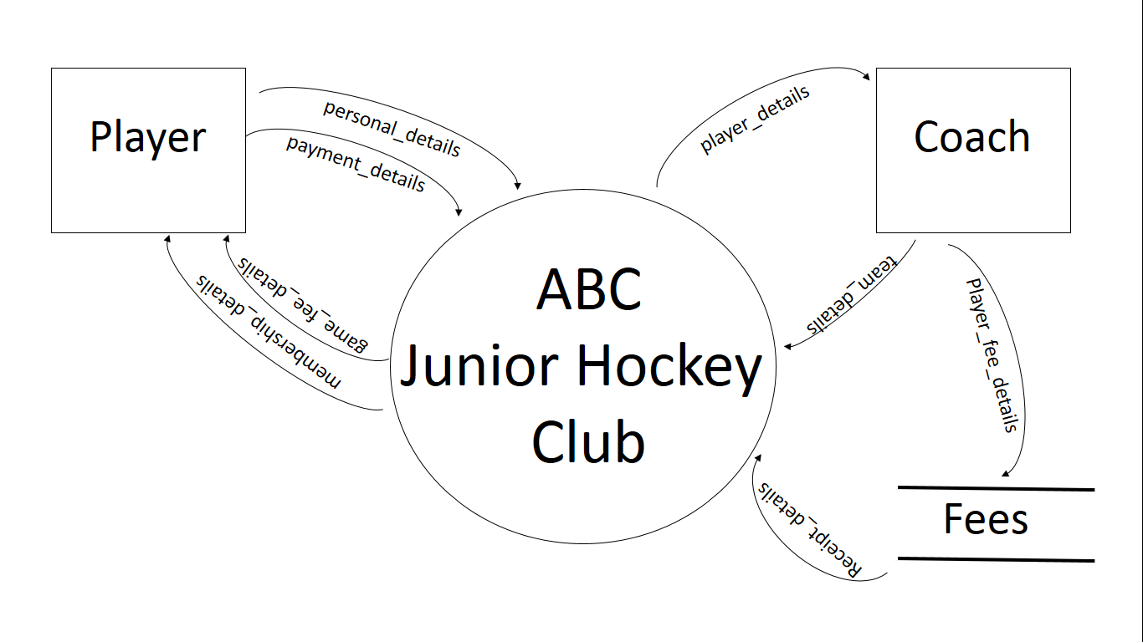

- What is the primary purpose of the large central circle? (1 mark)
Description | Mark
It is to state the scope/boundary of the system being analysed | 1
Total | 1
- Identify an error in the diagram. (1 mark)
Description | Mark
Data store Fees is in the diagram and should not be | 1
Total | 1
There are a few errors that are there because of the Fees store, any of these can be identified.
Data flow from Coach to Fees and flows from Fees to system.
- What is the purpose of the squares in this diagram? (1 mark)
Description | Mark
These are Entities and are either the source or sink of data to and from the system. They show the data in and out. | 1
Total | 1

End of Section One
Section Two: Extended answer 60% (72 Marks)
This section contains three (3) questions. You must answer all questions. Write your answers in the spaces provided.
Spare pages are included at the end of this booklet. They can be used for planning your responses and/or as additional space if required to continue an answer.
  - Planning: If you use the spare pages for planning, indicate this clearly at the top of the page.
  - Continuing an answer: If you need to use the space to continue an answer, indicate in the original answer space where the answer is continued, i.e. give the page number. Fill in the number of the question(s) that you are continuing to answer at the top of the page.

Suggested working time: 75 minutes.
Question 21 (22 marks)

Starshine Insurance Ltd. are an insurance company that deals with car insurance. They are looking to expand into other areas of insurance including house, travel and pet. They have 30 employees based in a building in Perth, Western Australia. Currently, their system uses old technology and is very paper intensive. They have hired a systems analyst to review their current system for inefficiencies and to recommend changes going forward.

- The analyst has decided to use the Systems Development Life Cycle (SDLC).
Outline two reasons why the analyst has decided on this methodology instead of creating a prototype of a new system. (2 marks)
Description | Mark
It is a thorough way to create a solution | 1
Their current system needs new infrastructure and software as it is paper intensive | 1
Total | 2
Logical answers are valid
Time critical/safety critical/more than 20 people working on the system/client not very knowledgeable/legislative requirements for documentation.
- Describe two activities that the analyst will need to do in the Analysis stage. (2 marks)
Description | Mark
Data gathering may occur when the analyst will check what is wrong with the current system such as interviews, etc. | 1
They will draw CD and DFDs of the old system and look at how they can improve the organisation | 1
Total | 2
Other activities that are logical may be stated.
- Describe a tool that could be used in budgeting the project. (1 mark)
Description | Mark
A spreadsheet could be used to keep track of all expenses. | 1
Total | 1
Other answers that may be used could be CASE software, database, etc.
Using the following information answer question 21 d and e.
The analyst has uncovered the current quoting and purchase system.
A customer calls to request a car insurance quote. They give their personal details to the call centre person. The call centre person checks the type of car, age, mileage and location in the car spreadsheet and retrieves the price of the insurance. A quote is created and the quote details are given to the customer and filed in the quote spreadsheet. The customer has 30 days to respond to the quote. If the customer decides to purchase the insurance, they call and give the quote details. The call centre retrieves the quote from quote spreadsheet and confirms the details of both the car and personal details of the customer. A purchase order is then created and emailed to the customer. The customer has 30 days to pay for the insurance. Once paid, the customer receives the insurance policy and a receipt and the policy is saved in the policy spreadsheet.

- Draw the Context diagram for the quoting and purchasing system below. (5 marks)

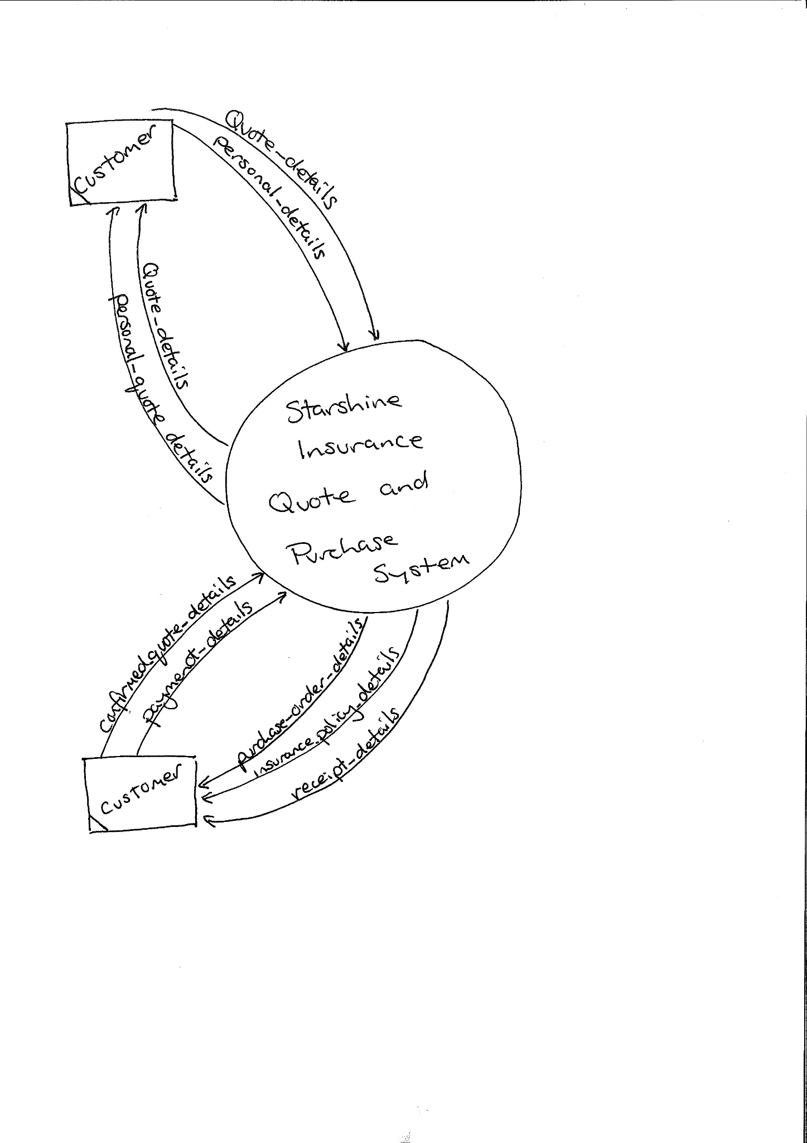
Entity – 1 mark
System boundary clear set – 1 mark
Flows – Personal details and quote details 1 mark
Flows – quote details from customer and personal quote details and confirmed quote details 1 mark
Flows – purchase order details, payment details and insurance policy and receipt details 1 mark

Total 5 marks

Students may name the flows a little different.

- Create the Level 0 Data Flow Diagram (DFD) for the system below. (12 marks)
Entity – 1 mark
Data stores – 3 marks
Processes – 4 marks
Flows - from the processes to Entity and data store are logical – 4 marks
Process names may differ as well flows. Should be numbered and follow guidelines.
Question 22 (14 marks)
Refer to the image below and answer the following questions.
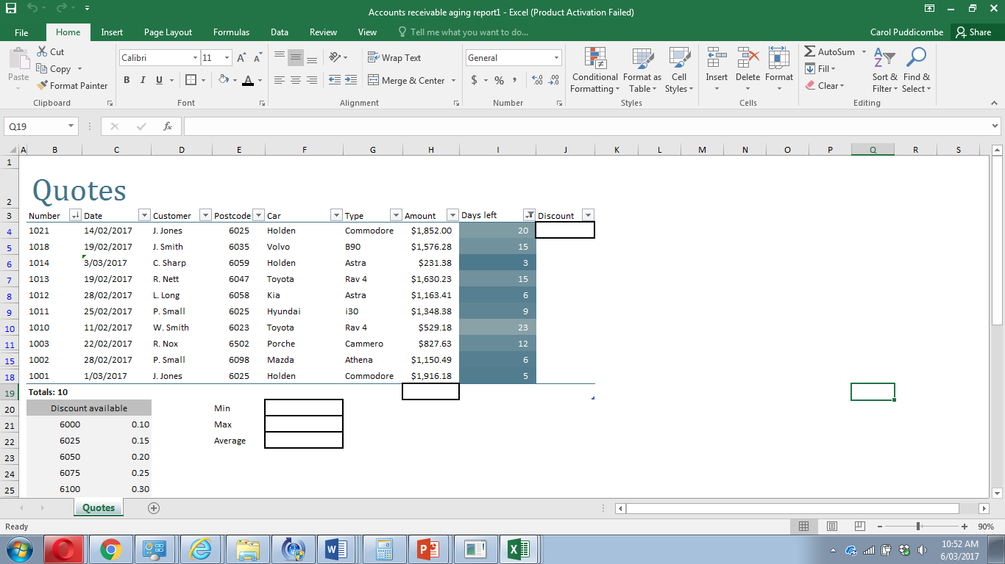
- What formula would be used in the Min cell F20 to find the minimum quote amount?
(2 marks)
Description | Mark
=Min(H4:H18)
=Min() – 1 mark and H4:H18 – 1 mark

Total | 2
- What formula would be used in the Max cell F21 to find the maximum quote amount?
(2 marks)
Description | Mark
=Max(H4:H18)
=Max() – 1 mark and H4:H18 – 1 mark

Total | 2
- What formula would be used in the Average cell F22 to find the average of all quotes?
(2 marks)
Description | Mark
=Average(H4:H18)
=Average() – 1 mark and H4:H18 – 1 mark

Total | 2
- What formula would be used in cell H19 to add all the amounts? (2 marks)
Description | Mark
=sum(H4:H18)
=sum() – 1 mark and H4:H18 – 1 mark

Total | 2

- A lookup formula is needed in J4 to find the discount based on the postcode. Write the formula that would be required. (5 marks)
Description | Mark
=vlookup(E4,B21:C25,2,TRUE)
=vlookup() 1 mark
E4 – 1 mark
B21:C25 – 1 mark
2 – I mark
TRUE – 1 mark
Total | 5
- What is required in the lookup formula to enable it to be copied down? (1 mark)
Description | Mark
Need to change the table array to absolute referencing.  Ie: $B$21:$C$25 | 1
Total | 1
Students may come up with other ideas without discussing absolute as it is not named specifically in the syllabus

Question 23 (26 marks)
The analyst has looked at the number of spreadsheets used and has suggested the company use a relational database. The claims spreadsheet is shown below. Use this to answer the following questions.
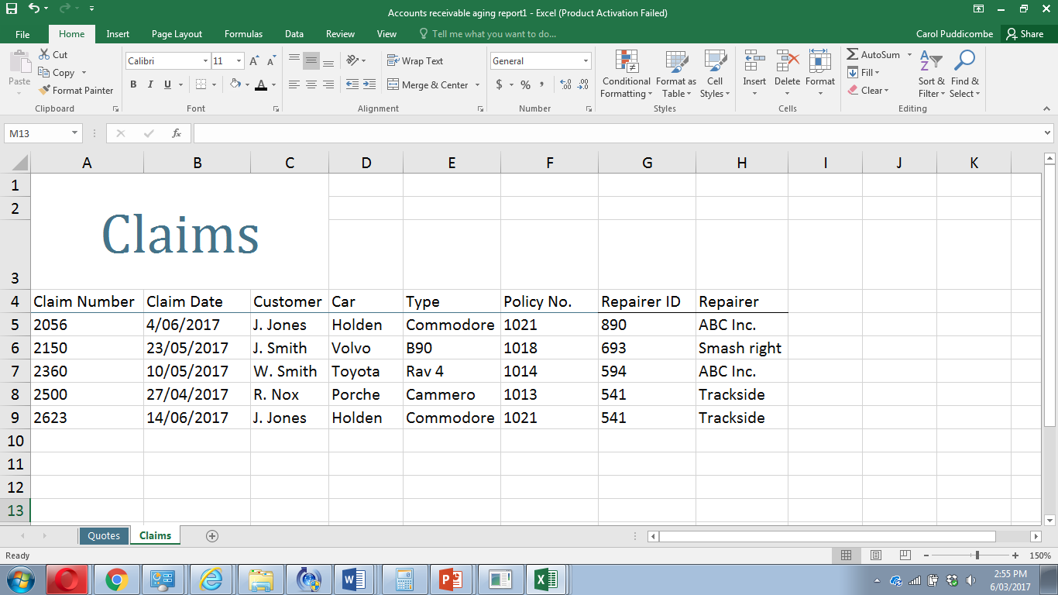
- Describe two issues using data from the spreadsheet that need to be sorted before moving to a database. (4 marks)
Description | Mark
Repeated fields like J. Jones appears twice | 1 + 1
Cells are not atomic like J. Smith has two items of data in cell | 1 + 1
Total | 4
Answer needs to have issue as well as named data for both marks

- Describe the following terms using data from the spreadsheet. (4 marks)
Description | Mark
Data integrity  The validity and accuracy of the data.  This has low data integrity as there is repeated data like J. Jones | 1 + 1
Data redundancy  The unnecessary duplication of data  This has high redundancy as there is repeated data like 1021 policy number | 1 + 1
Total | 4
Answers may talk about unnormalised data etc. That is ok as long as they use data from the spreadsheet in their answer.
- Identify the ideal data types for the following from the spreadsheet. (3 marks)

Description | Answer | Mark
Policy Number | Number | 1
Claim Date | Date | 1
Car | Text or string | 1
Total |  | 3

- The analyst has decided to change the spreadsheet into a database. Using your understanding of databases create an Entity Relationship Diagram (ERD) that would ensure high data integrity and low data redundancy. Ensure you use Chen’s notation. (13 marks)
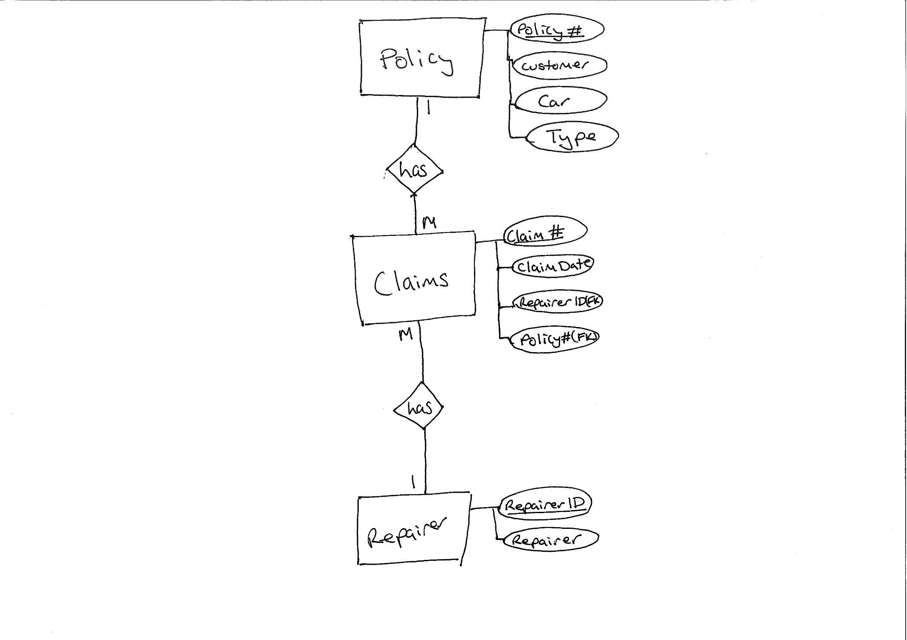Firstly, as you can see this is not to 3NF.
Some students may resolve all and put into 3NF but this is not part of the Syllabus. Do not penalise students if the go to 3NF.
3 marks for Entities
2 marks for Cardinality and relationship
3 marks for Primary keys
2 marks for Foreign keys
3 marks for the remaining attributes in the corrects places.
- Describe two legal requirements of keeping customers personal information that organisations need to comply with. (2 marks)
Description | Mark
You need to ensure that it is safe from unauthorised personnel | 1
You need to destroy all information once you have finished with it | 1
Total | 2
Regulations of the privacy act
Question 24 (10 marks)
The analyst has recommended that Starshine Insurance Inc. standardise their hardware for their assessors so that it would be easier to maintain. Currently, the assessors write down everything in a pad, return to the office and enter the details. It would be much easier for them to have a device of some sort that they could carry with them.
The analyst has given them two choices outlined below.
Choice 1 | Choice 2
Lenovo Miix 510-9Y 12” 2-in-1 Laptop  $998.00 | Microsoft Surface 3 LTE - 128GB  $1069.00
Intel Core i3, 2.3 GHz, 3MB Cache, RAM DDR4 8GB, SSD 128GB, 12 inch screen, multi-touch, HD Graphics inbuilt, wireless, Bluetooth, Windows 10, 12 month warranty  Keyboard and removable display | Quad-core intel i7, 2.4 GHz, 2MB Cache, RAM 4GB, SSD 64GB, 10.8” screen, multi-touch, inbuilt graphics, wireless, Bluetooth, Windows 10 Pro, 2 year warranty  Keyboard and removable display
Decide which one the organisation should choose for this specific purpose. Justify your decision, using your knowledge of primary and secondary storage and key hardware and software components required for a computer system for Starshine. Choice
Description – Choice is irrelevant. Answers need to include the following with justification. : | Mark
CPU type Core i3 vs quad core i7 | 1
Cache – 3 vs 2 | 1
RAM DDR4 8GB vs RAM 4GB | 1
SSD 128GB vs SSD 64GB | 1
Screen size | 1
High def graphics vs non HD | 1
Windows 10 vs Pro | 1
12 month warranty vs 2 years | 1
Cost 998 vs 1069 | 1
2.3 vs 2.4 GHz | 1
Total | 10

